

**Arellano University**

Jose Rizal High School

Gov. Pascual Ave. Mal. City

Tel/Fax #921-27-44

Senior High School Department

# **ENTREPRENEURSHIP**

S.Y 2018 – 2019



## **MEMBERS**

Vherniel L. Lebis

Covie-Celdrin P. Lagasca

Kean Jorell O. Nobleza

Jhonrey A. Tismo

Jeremiah M. Felipe

Arnel Bruza

Brent Maverick Chico

Ace Reyes

Kyla Malicsi

Cristel Marie D. Santos

Chezca Mae Pedernal

Denica Mae Jimenez

Noah Marie Suguilon

Marielle Camila Tibig





**WE DON’T JUST FINISH IT,**

**WE TAKE CARE OF IT.**



## **INTRODUCTION**

ITMA ® is a large-scale international web and multimedia service company based in Manila – Philippines. ITMA ® operates high quality and international level services in both all aspects of Web and Multimedia Services. It utilized by the latest technologies and equipment to turn ideas into higher quality products.

## **THE GOAL OF COMPANY**

ITMA ® ensures that every service conforms to international best practices to make everything efficient and trustworthy and to meet their needs or requirements for their own companies. Our client’s best interest will always come first, and everything we do will be guided by our values and professional ethics. Establishing the client’s trust and long-term partnership is our goal to achieve success.

## **SERVICES**

ITMA ® offers a high quality and international level services in both all aspects of Web and Multimedia Services. These services are carefully planned, discussed, and created and utilized by the latest technologies and equipment to turn ideas into higher quality products. Every service conforms to international best practices to make everything efficient trustworthy.

## **THE MARKET**

The market has a wide range of both corporate and individual clients who cannot successfully run their businesses without the services of ITMA ®. We will ensure that all of our web and multimedia services is well accepted in the market place. Our specifically target clients are Insurance Companies, Corporate Organizations, Manufacturers, Government, Schools, Hotels, Casinos, Celebrities, Politicians, Organizations, Television Stations, Publishing Houses, Branding, Advertising agencies, Entrepreneurs, and Start-ups.

## **FINAL CONSIDERATION**

We have a team of creative and highly proficient developers, designers, photographers, and videographers. It is a great opportunity to approach this kind of business in the industry due to the needs of having a web and multimedia content to their own company. In addition, they don’t need to hire multiple individuals to make the content for their companies. Instead, we offer a complete set of both web and multimedia services all in one place



## **INTRODUCTION**

ITMA ® is a large-scale international web and multimedia service company based in Manila – Philippines. ITMA ® operates high quality and international level services in both all aspects of Web and Multimedia Services. It utilized by the latest technologies and equipment to turn ideas into higher quality products.

## **BACKGROUND AND HISTORY**

ITMA ® begun in Malabon City in 2015 when Mr. Vherniel L. Lebis, CEO of ITMA ® who had working as a freelance web developer and web designer for six years began as a small-scale local web and multimedia service company. For the next couple of years, ITMA ® grew rapidly due to Mr. Vherniel L. Lebis’s excellent idea of combining Web Service and Multimedia service all in one place. As it grows, ITMA ® became a large-scale international company and begun to bid for larger projects successfully.

## **THE GOAL OF COMPANY**

The goal of ITMA ® are to provide small, medium, and large companies who wants to make their business look more high-quality and professional. We ensure that every service conforms to international best practices to make everything efficient and trustworthy and to meet their needs or requirements for their own companies. Our client’s best interest will always come first, and everything we do will be guided by our values and professional ethics. Establishing the client’s trust and long-term partnership is our goal to achieve success.

## **MISSION**

To deliver innovative, high-quality, and professional web and multimedia business-centered services by utilizing the latest technologies to help companies prosper and grow.

## **VISION**

To be a leading web and multimedia service company that provides latest technologies, professional content, and innovative products to companies.



ITMA ® offers a high quality and international level services in both all aspects of Web and Multimedia Services. These services are carefully planned, discussed, and created and utilized by the latest technologies and equipment to turn ideas into higher quality products. Every service conforms to international best practices to make everything efficient trustworthy.

## **WEB SERVICES**

* Content Management System
* Shopping Cart / Online Ordering System / Online Payment System
* Event Booking System
* Membership System
* Blog / News Management
* Business Directory / Listings
* Social Media Integration – Facebook, Twitter, YouTube, Google+, etc.
* Email Newsletter
* Mobile-Optimized Website
* Printer-Friendly Website
* Password-Protected Pages / Client Area
* Web Application
* Online Business Software
* Mobile Application / iPhone App / Android App
* Word Press Web Development
* Search Engine Optimization Services and Code Writing Services
* Other web design related services

## **MULTIMEDIA SERVICES**

* Photography
* Filmmaking
* Graphic Design
* Web Design
* Television Advertisement
* Typography
* Logo Design
* Advertisement
* Mobile Application Design
* Packaging Design

## **SERVICE STRATEGY**

After every successful project that had been done. We ensure that It will not end there. We ensure that we will innovate the product and provide maintenance for it every month. We also give a special discount if they want to add features and improve their content.



ITMA ® is committed to a professional area of web and multimedia business. In order to be a leading company and in order to favorably compete at large competition of web and multimedia services, we conducted a SWOT analysis to make a well-structured web and multimedia business company. Here is a summary from the result of the SWOT analysis that was conducted on behalf of ITMA ®

## **STRENGTHS**

Our strength lies in the power of our team and our workforce. We have a team of creative and highly proficient developers, designers, photographers, and videographers. We are a team with excellent qualifications and experience various areas in the web and multimedia service industry. We also specialize the best practices to make everything efficient and trustworthy. With that, we are able to bring a wide variety of service to our clients that overcome their expectations.

## **WEAKNESSES**

Our major weakness is that our pricing is too much expensive for other starting companies especially when they need just at least small amount of web and multimedia contents.

## **OPPORTUNITIES**

The web and multimedia industry are growing fast and becoming in demand to companies. It is a great opportunity to approach this kind of business in the industry due to the needs of having a web and multimedia content to their own company. In addition, they don’t need to hire multiple individuals to make the content for their companies. Instead, we offer a complete set of both web and multimedia services all in one place for them without hiring a lot of individuals to work for them with different pricing. Unlike us, we guarantee that our services had a fixed price depending on what they want for their own company instead of giving the salary to individuals with different amount of money.

## **THREATS**

As a large-scale company, there are several highly competitive companies that we might be facing. Especially when they arrive in the same market location and they may want to adopt the same business model like us. Another threat that we are likely going to face is economic downturn. It is a fact that economic downturn affects purchasing / spending power



## **ORGANIZATION CHART**

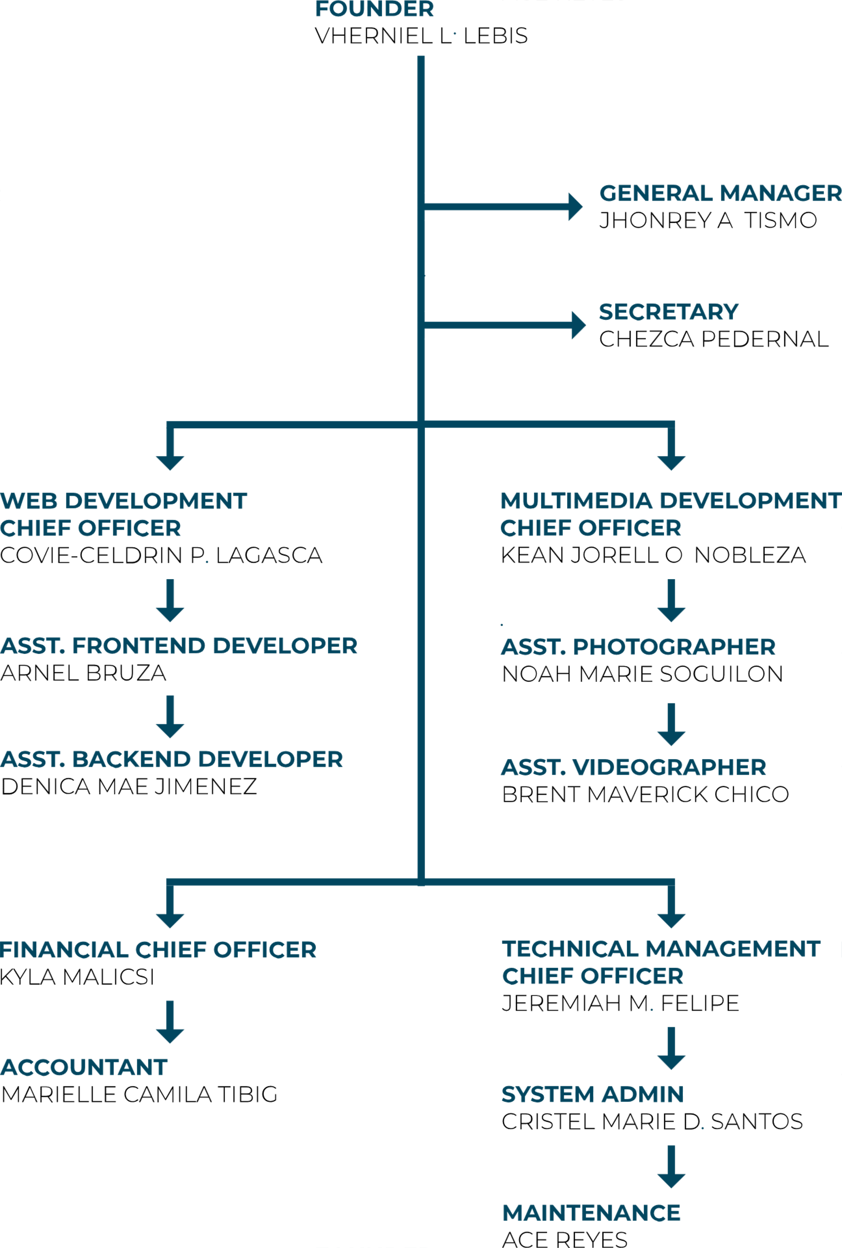



**TARGET MARKET**

Based on the results of our research, there is a wide range of both corporate and individual clients who cannot successfully run their businesses without the services of ITMA ®. In view of that, we have conducted our market research and survey and we will ensure that all our web and multimedia services is well accepted in the market place. Below is a list of the people and organizations that we have specifically market our and services to;

* Banks, Insurance Companies and other related Financial Institutions
* Corporate Organizations
* Manufacturers and Distributors
* Research and Development Companies
* Government
* Schools (High Schools, Colleges and Universities)
* Celebrities, Politicians, Public Figures and Public Speakers
* Television Stations
* Printing Press (Publishing Houses) and Authors
* Branding and Advertising agencies
* Entrepreneurs and Start – Ups

## **MARKET TRENDS**

The trend in web and multimedia services industry is that the target market is continuously expanding. People and organizations are now seeing the need for them to have an official website or campaign video. They also engage the services of graphic designers and videographers in their advertisements that will help them communicate their brand to a wide range of clients.

**ADVERTISING STRATEGY**

To advertised our web and multimedia services. We conducted these strategies that will help us walk our way into the center of our target market. We aim to become the number one choice for both corporate clients and individual clients in the world which is why we have made provisions for effective advertisement of web and multimedia services company.

Below are the platforms we intend to advertise on to promote and advertise ITMA ®;

* Place adverts on both print (newspapers and magazines) and electronic media platforms
* Advertise on the internet and social media platforms like Instagram, Facebook, twitter, YouTube, Google +, et al to promote our services.
* List our company name and services in local directories / yellow pages
* Advertise our web cum graphic design company in our official website and employ strategies that will help us pull traffic to the site.
* Ensure that all our staff members wear our branded shirts and all our vehicles are well branded with our company logo et al.



## **PRICING STRATEGY**

The prices of our services ranges between average to expensive market rate for all of our clients because the value of our professional services and skills are the same value of their business. We also offer a special discount to all clients if they want to add features and improve their content.

We are aware that there are some one – off jobs or government contracts which are always lucrative, we will ensure that we abide by the pricing model that is expected from contractors or organizations that bid for such contracts.

## **SOURCE OF INCOME**

ITMA ® is established with the aim of maximizing profits in the web and multimedia service industry and we are going to go all the way to ensure that we do all it takes to make everything efficient and trustworthy and to meet their needs or requirements for their own companies. Our client’s best interest will always come first, and everything we do will be guided by our values and professional ethics ITMA ® will generate income after finishing every work or services to our clients.

## **PAYMENT OPTIONS**

At ITMA ®, our payment policy will be all inclusive because we are quite aware that different people prefer different payment options as it suits them.

Here are the lists of payment options that we will make available to our clients;

* Payment by via bank transfer
* Payment via online bank transfer
* Payment via check
* Payment via bank draft
* Payment via mobile money
* Payment with cash